Assignment No.

Title of Assignment: A Dictionary stores keywords & its meanings. Consider dictionary data is stored in a file in random order. Thus, to search any the word & its meanings from given data, program should create reasonably balanced tree
Relevant Theory:

AVL TREE: AVL means Adelson- Velskii and Landis tree.

AVL tree property: For every node in the tree, the height of the left and right subtrees differs by at most 1.
An AVL tree is a height balanced search tree. For any node in an AVL tree, the height of the left subtree and right subtree differ by at most 1. Why is this important? The time to search an average unbalanced tree is 1.39 * logn as opposed to logn for a balanced tree.

Each node of an AVL tree has a balance factor associated with it.

class node
{
char keyword[20];
char meaning[20];
class node *left, *right;
int bf; // balance factor either -1, 0, +1
};

The balance factor of a node is h_{L} – h_{R} where h_{L} is the height of its left subtree and h_{R} is the height of its right subtree. As soon as a node’s balance factor becomes +2 or –2, it is rebalanced and balance factor becomes 0.

There are two types of rotation:
1) Single Rotation
2) Double Rotation

- Single Rotation:
a. Left Left Rotation
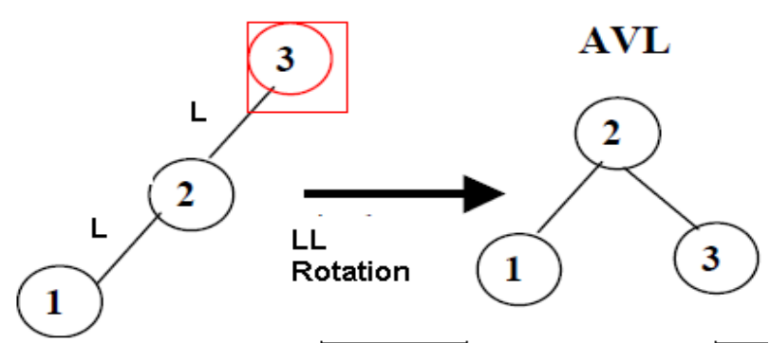

b. Right Right Rotation
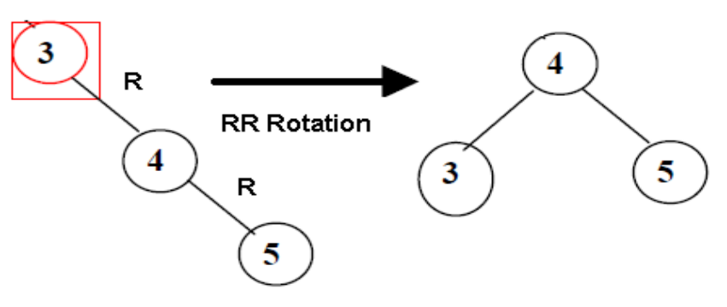
- Double Rotation:
a. Left Right Rotation
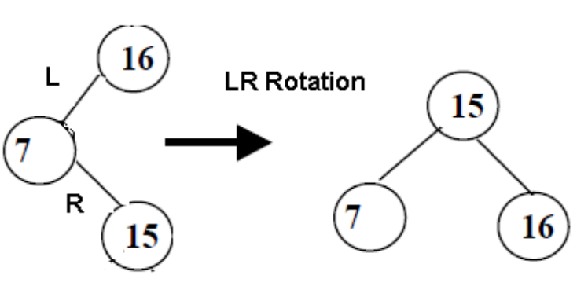
b. Right Left Rotation
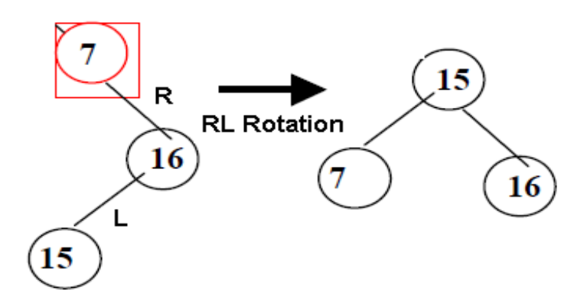
Example:
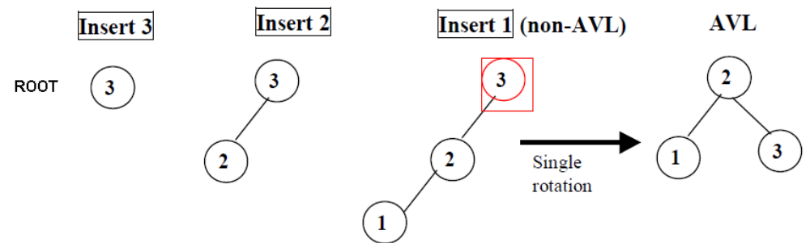

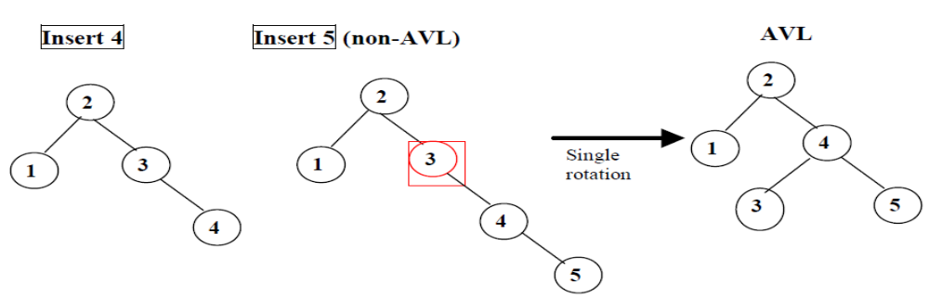
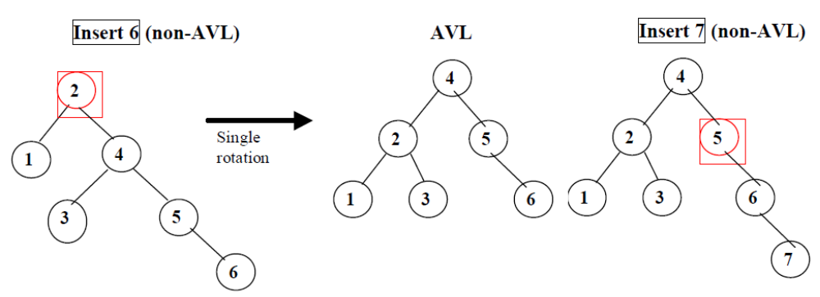

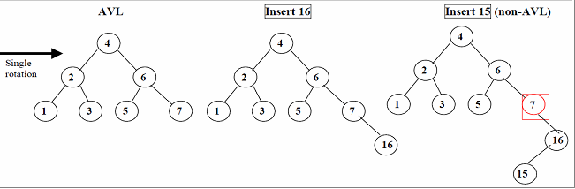

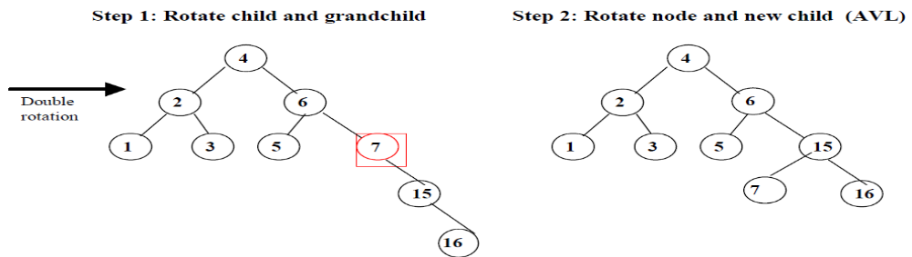

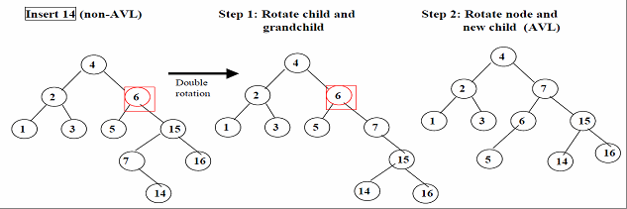
ALGORITHM:

Create Function:
Step 1: Start.
Step 2: Take data from user & create new node n1.
Step 3: Store data in n1 & make left & right child “NULL” and balance factor
(BF) = 0
Step 4: If root is “NULL” then assign root to n1.
Step 5: Else call insert function & pass root & n1.
Step 6: Stop.

Insert Function:
Step 1: Start.
Step 2: We have new node in passed argument; so check data in temp is less than data in root. If yes then check if Left child of root is “NULL” or not. If yes, store temp in left child field of root and calulate balance factor of predecessors and perform left left rotation or left right rotation according to BF.otherwise call insert function again & pass left address of node & temp.
Step 3: If data in root is less than data in temp then check if right child of root is “NULL”. If yes then store temp in right child field of root calulate balance factor of predecessors and perform right right rotation or right left rotation according to BF.& if not call insert function again & pass right child address of node & temp.
Step 4: Stop.

Inorder Function:
Step 1: Start.
Step 2: Taking root from inorder function, check if it is “NULL” or not.
Step 3: Again call inorder function & pass left child address of node
Step 4: Display data of root.
Step 5: Again call inorder function & pass right child address of node.
Step 6: Stop.

Search Function:
Step 1: Start.
Step 2: If root is “NULL” then display tree is not created.
Step 3: Read the key to be searched in a variable, say k.
Step 4: Search for the key in the root, left and right side of the root.
Step 5: Display appropriate message for successful and unsuccessful search.
Step 6: Stop

Main Function:
Step 1: Start.
Step 2: Create necessary class objects & declare necessary variables.
Step 3: Print menu as below & take choice from user:
1. Create
2. Display
3. Search
4. Update
5. Delete
6. Exit
Step 4: If choice is 1, call create function.
Step 5: If choice is 2, call display function.
Step 6: If choice is 3, call search function.
Step 7: If choice is 4, call update function
Step 8: If choice is 5, call delete function
Step 9: If choice is 6, then exit.
Step 10: Ask user whether he wants to continue or not.
Step 11:If yes then go to step 3.
Step 12: Stop.
Mathematical Modelling:
Let I be a set of Inputs {n, i_{n} } where n is no. of keywords of dictionary & i_{n} is an individual node values which stores keyword & its meaning.
Let O be a set of Outputs {C, Dk, S } where
C is Create Dictionary function = c(I) = L (c is function of create which gives output as a L set of keywords & its meaning of dictionary)
Dk is display keyword function = dk(L) = i_{n} (dk is display function on L which gives output as i_{n} an individual node values stores keyword & its meaning)
S is Search keyword Function = s(L) = a (s is search function on L which gives output as a where a € A = {Keyword Found, Keyword Not Found} )
Testing:
Test Conditions:
Dictionary keywords and its meaning are stored in random file. Perform the rotation LL, RR, RL & LR while creation. Also display AVL tree and search particular keyword.

Input:
Dictionary keywords and its meaning are stored in random file. Enter keyword which you want to search.

Output:
Menu:
  - Create
  - Display
  - Search
  - Update
  - Delete

FAQs:
- What is Balanced Tree?
- What is AVL?
- What is LL, RR, RL and LR Rotations?
- What is Advantages of AVL Tree?
- What is balancing factor?
Conclusion: Performed the operations on balanced tree i.e. AVL tree.

